**Project Design Phase-I**

**Solution Architecture**

|  |  |
| --- | --- |
| Date | 19 September 2022 |
| Team ID | PNT2022TMID11922 |
| Project Name | Personal expense tracker |
| Maximum Marks | 4 Marks |

**Solution Architecture:**

An architecture bridges the gap between business problems and technology solutions through a complex process with many sub-processes. As a result, it aims to:

●     Analyze existing business problems and find the best tech solution.

●      Describe the structure, characteristics, behavior, and other aspects of the software to project stakeholders.

●      Define the features and phases of the development process, as well as the requirements of the solution.

●  Develop specifications for defining, managing, and delivering the solution.

**Technical Architecture:**

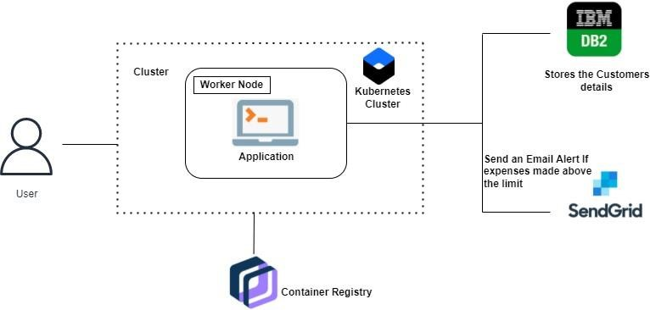

**Solution architecture:**

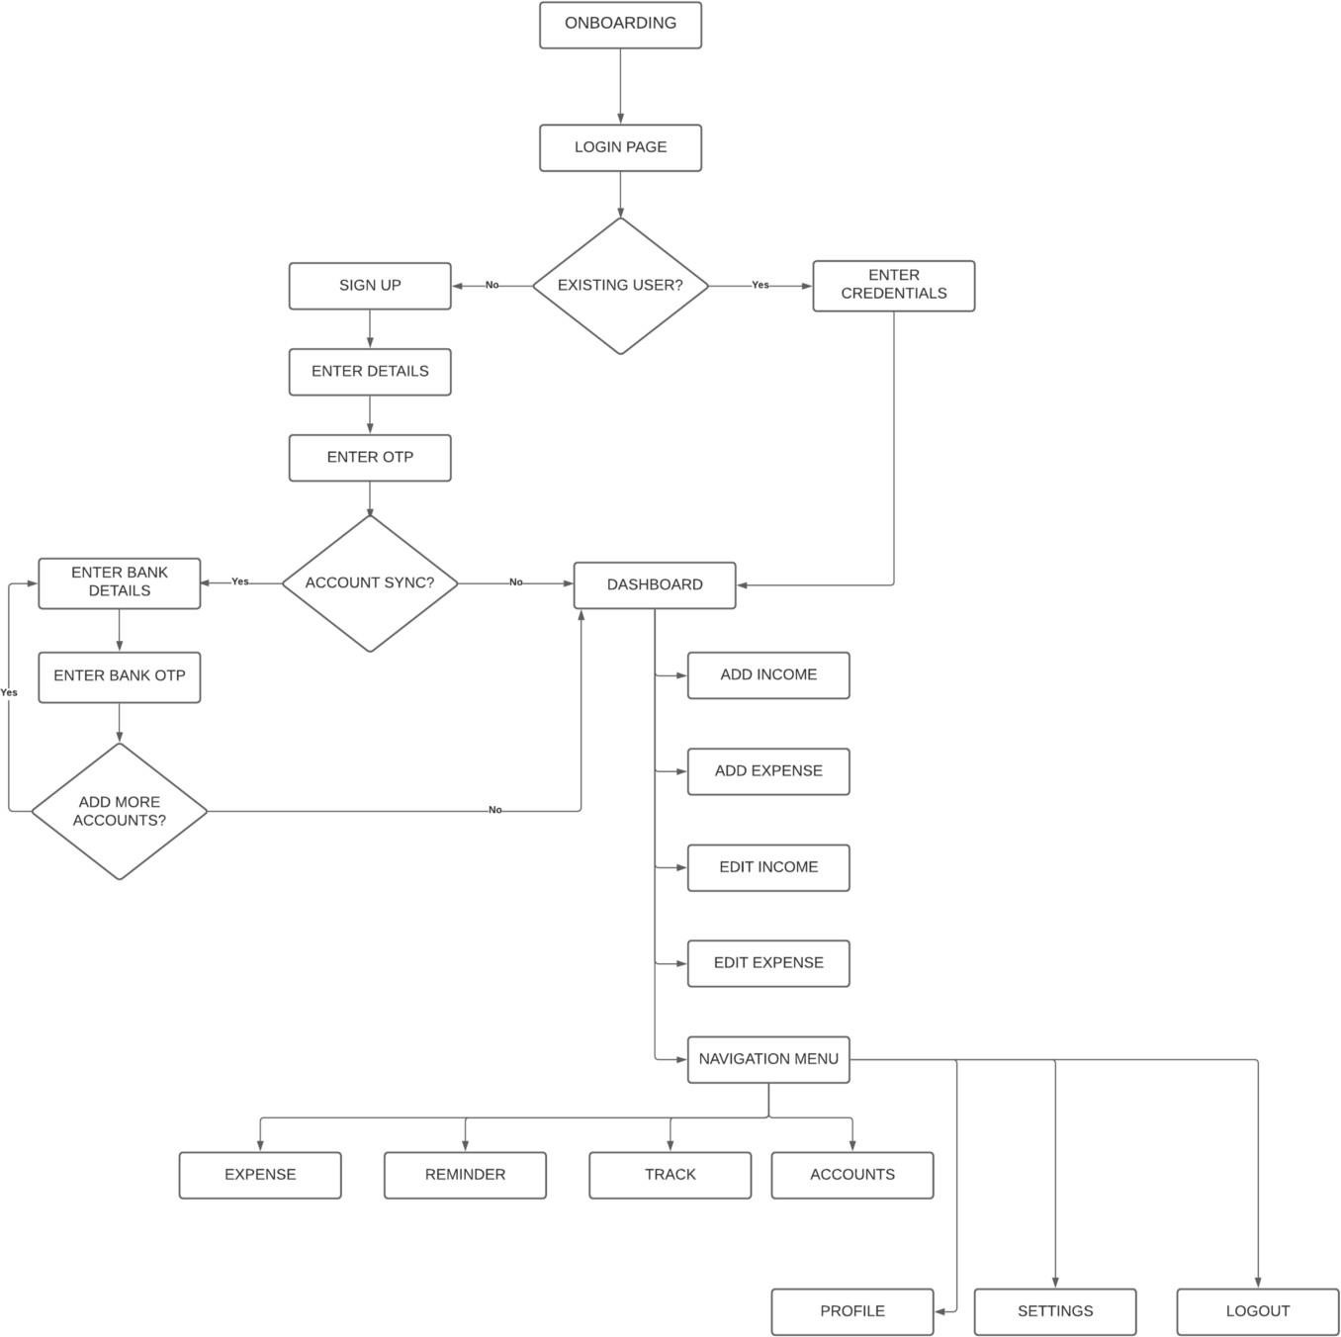

# EXAMPLE-SOLUTION ARCHITECTURE

